Develop a Mobile Application

|  |  |
| --- | --- |
| Date | 17 November 2022 |
| Team ID | PNT2022TMID49268 |
| Project Name | Project – Smart Farmer-IoT Enabled smart Farming Application |

Creating Mobile app using MIT app Inventor SMART FARMER APPLICATION

Blocks

QR Code for APK download:

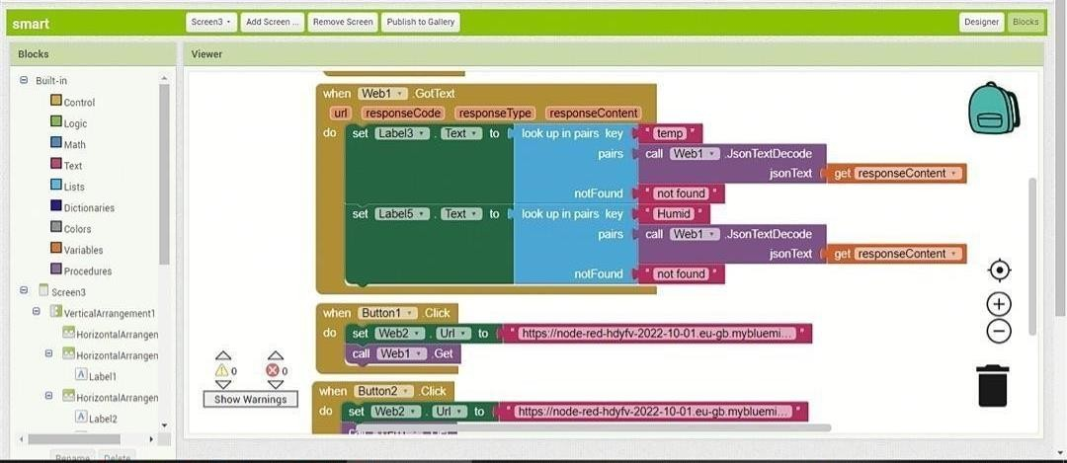

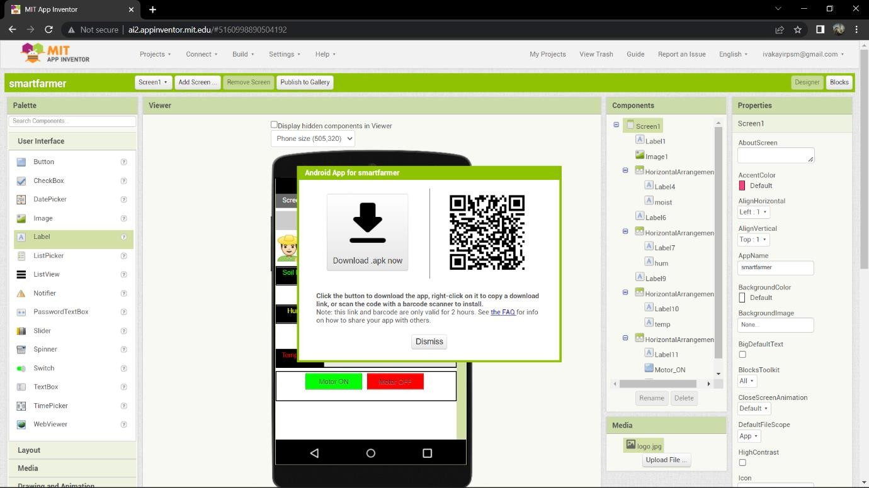

Output Screen in Mobile :

